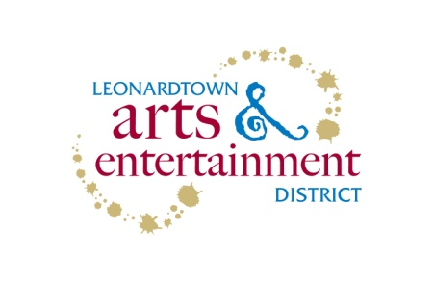

Town of Leonardtown - Public Art Project
Request for Proposal

The Town of Leonardtown’s Arts and Entertainment District, in conjunction with the St. Mary’s County Arts Council and the Maryland State Arts Council, is seeking proposals from professional muralists/painters interested in creating a mural to be painted on the north concrete wall of the Hair Company Building in Leonardtown, MD that reflects the history and revitalization of the Leonardtown waterfront. The winning proposal/artist will create a mural/murals that are appropriately durable for an outdoor installation, and they can be abstract or representational. Several sample pages of murals of the styles that the committee has considered as possible models are attached for example only. Also included are photos of the historical waterfront as well as the Leonardtown Wharf waterfront today. The artist needs to be a resident of the state of Maryland.

Site Description:
The address of the Hair Company Building is 22740 Washington Street, Leonardtown if you wish to visit the site in person. The site has three possible areas available for mural work. The first is approximately 33 feet wide, the second is approximately 16 feet 6 inches wide, and the third is 14 feet wide. Each area is separated by a two foot wide brick divider. Height is variable. See attached photo. These areas will be visible to pedestrians and drivers heading south on Washington Street. The wall surface is stucco. One or more of the sections of the building may be utilized. The Town, in conjunction with the building owner, is working to refresh the remaining walls of the building.

Budget:
The total project cost cannot exceed $10,000 and the muralist will be responsible for all paint, brushes, scaffolding and other supplies needed to complete the project. The attached budget sheet must be filled out and returned. The muralist will be responsible for preparing the site for the mural in accordance with Golden Acrylic Artist Colors; http://www.goldenpaints.com/technicaldata/murals.php. The town will assist with developing a plan for any sidewalk or street closures needed during the installation of this artwork. Artists can propose working alone, with partners or hiring assistants to complete the project.

Submission Requirements:
In one or two pages, describe the proposed project, including concept and approach, medium, proposed schedule or timeline for design and implementation, budget and approximate dimensions of the proposed murals. Include photographs and/or drawings to be used for the committee’s evaluation. Please submit, along with the signed application, the following items:

- A CD with at least 5-10 examples of your most representative work. Please include title, media, dimensions, location and date of work, if applicable.
- Protective Coating - A suggested method for a protective coating that will be applied to the mural after completion.
- Maintenance Plan - Describe the material and processes used (so that repairs can be made) and a schedule of required maintenance (such as the replacement of an anti-ultraviolet coating, how repairs will be made, inspections and maintenance, etc.).
- References - Provide a minimum of three (3) references for muralist services for organizations for whom you have provided similar services. The references should include, at a minimum, the name of the organization, the address, the contact person, title, email address and a telephone number.
- Certification of Liability Insurance is required.
- Your most recent resume

Please note: application materials will not be returned.

.
Timeline:
Monday, March 12, 2018 – Application deadline (received by 4:00 pm)
Between March 26th and April 2nd – Winning artist will be notified
Friday, April 13, 2018 – Grant proposal submitted to MSAC

Selection Process:
The Leonardtown Public Art Committee, consisting of artists, a community art advocate, the Leonardtown Town Administrator and the Executive Director of the St. Mary’s Arts Council, will evaluate the submissions. The projects will be evaluated based on the following: artistic merit – based on the criteria listed above, appropriateness of budget, and visual impact/visibility, of the project. An artist may be selected directly from the initial submitted applications or the committee may elect to invite a short list of finalists for further interviews.

Contact Information:
Please address all questions to:
Laschelle McKay
PO Box 1
22670 Washington Street
Leonardtown, MD 20650
301-475-9791
Laschelle.mckay@leonardtownmd.gov

Completed proposals should be submitted by Monday, March 12, 2018 at 4:00 pm to the above address.

