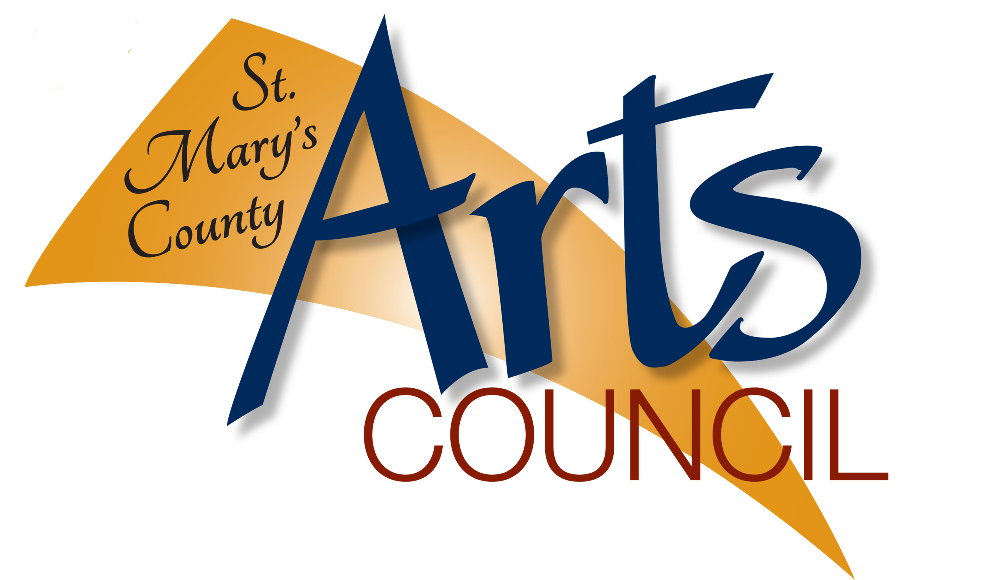 | OFFICE USE ONLY  GRANT #
 | NAME OF ORGANIZATION
 | DATE OF APPOVAL
 | AMMOUNT OF GRANT

ST. MARY’S COUNTY ARTS COUNCIL
COMMUNITY ARTS DEVELOPMENT GRANT
FINAL REPORT

PROJECT DESCRIPTION

What was your project, when and where was it held? Was it an annual event or a one-time special project? Was it done solely by your organization or in conjunction with other organizations? Please answer these questions and describe your event in such a way that someone who missed it knows exactly what occurred. (Please attach on an additional sheet of paper.)

PROJECT IMPACT

How many people attended, viewed or otherwise benefitted from your project?

How many artists participated in your project?

PROJECT EVALUATION

Please evaluate your project. What aspects went well or better than expected, and what aspects failed to meet your expectations? Reasons for any success or things that could be improved should be noted along with your future plans to continue the successful aspects and change the less successful ones. Were there any challenges that the Arts Council could address and help with for next time. (Please attach on additional sheet of paper)
FINAL REPORT FINANCIAL STATEMENT

Project title:
CASH INCOME | CASH EXPENDITURES
SMCAC GRANT AWARD: | PERSONEL FEES (itemize):  Artistic:  Technical:  Administrative:
ADMISSION INCOME: | SPACE/RENTAL:
MEMBERSHIP INCOME: | EQUIPMENT RENTAL:
CASH CONTRIBUTIONS: | SUPPLIES & MATERIALS:
FUNDRAISING PROJECTS: | PROMOTION/PUBLICITY:
APPLICANTS FUNDS: | TRAVEL:
GOVERNMENT & OTHER GRANTS (Specify): | OTHER (Itemize):
TOTAL CASH INCOME: | TOTAL CASH EXPENDITURES:
IN-KIND ALLOWABLE:  (As outlined below) | IN-KIND ALLOWABLE:  (As outlined below)
TOTAL PROJECT INCOME: | TOTAL EXPENDITURES:

In-Kind services involved in the program/event may be listed here. These are the services that ordinarily would be paid for by your organization but are being voluntarily contributed to help you carry out your activities. The test for In-Kind contribution is this:
If the service was not being donated or the item contributed, would your organization pay for that service item? If the answer is yes, then it is a valid In-Kind contribution that you may claim.
UNDER NO CIRCUMSTANCES CAN MORE THAN ONE-FOURTH OF THE TOTAL PROJECT BUDGET BE IN-KIND SERVICES.
Salaries
Equipment
Fees
Supplies and Materials
Travel
Rental
Other (Itemize):

Total In-Kind
(Use one-fourth of this figure)

I hereby certify that the information and financial figures contained in this final report form are true, accurate, and represent the actual income and expenses of the project for which it was made.

Signature Title

Please attach copies of publicity materials, ads, programs, flyers, newspaper clippings, etc. and return by email to: info@smcart.org, by US Postal mail to: St. Mary’s County Arts Council, PO Box 1310, Leonardtown MD 20650, or hand-deliver during open office hours.

If submitting via the US post office be sure to send us an email that the report has been mailed.

Form Revised 9-20-2022

