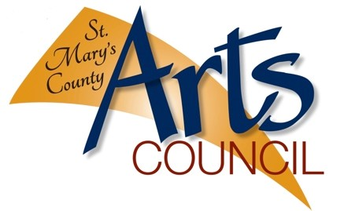
Volunteer Application for St. Mary’s County Arts Council (SMCAC)
Application Date ______________________ *** please print for all areas

Name ________________________________________________________________________

Home Address _________________________________________________________________

Phone Number_________________________________________________________________

Email_________________________________________________________________________

A Little Bit About You! Skills, hobbies, interests: ______________________________________

______________________________________________________________________________

Groups, clubs, organizational memberships, past work or volunteer experiences:

______________________________________________________________________________

______________________________________________________________________________

Why would you like to volunteer with St. Mary’s County Arts Council?

______________________________________________________________________________

______________________________________________________________________________

Areas of Special Interest: (Check one or more, detailed event info will be provided as needed. Assist required may be in part-time shifts depending on length of activities. We appreciate any support that our volunteers are available for!).

_____ Annual SMCAC Fundraiser – (date TBA) – help procure in-kind donations, event set-up and clean-up, assist at check-in/ info/ etc. tables, general assistance as needed.

_____ Art Walk (every September First Friday) – distribution of artwork to local shops two days prior to event, on event day assist outside vendors/ guests to find their space locations, distribute and receive voting ballots, provide info about SMCAC, give tours of Gallery & Gift Shop, assist outside w/ set-up and tear down of cones and with SMCAC affiliated activities at Leonardtown Square.

_____ First Fridays – 5 to 8 PM) – greet guest artists and attendees, provide info about SMCAC, give tours of Gallery & Gift Shop, other tasks as related to special events/ art receptions, assist w/ set-up and/or clean-up.
`
_____ Juneteenth Celebration – (annually mid-June, from noon to 5 PM) at Lancaster Park in Lexington Park, assist children w/ crafts, provide info about SMCAC at outdoor table.

_____ Patuxent River Naval Air Museum Technology & Arts Expo – (annually in March, from 10 AM to 5 PM), assist at SMCAC table w/ hands-on art activities.

_____ I am open to assisting whenever there is a need and if I am available, just ask me!

_____ Other____________________________________________________________________

Please read the following carefully before signing this application:
I understand that this is an application for and not a commitment or promise of volunteer opportunity. By signing below, I agree to hold harmless St. Mary’s County Arts Council, the Town of Leonardtown, and any other associated affiliates free of any liability due to personal harm or injury that (however unlikely) may occur. Volunteers must be age 16 and up, minors will need application co-signed by parent or legal guardian. I also give photo release consent as my image may appear in SMCAC or related media platforms of various types.

I will uphold the principles of respect for all others during my volunteer time regardless of race, gender, or individual beliefs. The SMCAC reserves the right to terminate this agreement at any time per decision by the SMCAC staff/ Board Members.
Signature __________________________________________ Date ______________________

**********************For Office Use Only****************************************

Reviewed and approved by:

SMCAC Representative #1 _______________________________ Date ____________________

SMCAC Representative #2 _______________________________ Date ____________________

Contact made to volunteer to give approval or denial of application: ___________ (staff initials)

Notes: ________________________________________________________________________

_____________________________________________________________________________

* Application updated 1/6/2023

